Agreement Between Yale Robbins Publications LLC (“Management”) and the Exhibitor Listed Below

The New Jersey Cooperator's Premier Co-op & Condo Expo, Wednesday, May 9, 2012 at
the Meadowlands Exposition Center, 355 Plaza Drive, Secaucus, NJ
1. Exhibition Booths & Sponsorship Opportunities (all prices include carpeting, table & 2 chairs)
Corporate Sponsor  Show Sponsor  Prime Booth  Deluxe Booth  Badge Sponsorship  Food Court Sponsorship  Aisle Sign Sponsorship |  |  |  |  |  |  |  |  |  |  |  |  |  |  |  |  |  |  |  |  |  |  |  |  |  |  |  | $8,150  $3,050  $2,350  $1,850  $4,000  $1,500  $750
Sub Total |  |  |  |  |  |  |  |  |  |  |  |  |  |  |  |  |  |  |  |  |  |  |  |  |  |  |  | $
2. Packages:
The Penthouse Deluxe - Booth, Full Pg. Ad in the Expo Program Guide, Full Pg. Ad in NJ Cooperator,  Free Standing Insert in the Expo Distribution of The NJ Cooperator |  |  |  |  |  |  |  |  |  |  |  |  |  |  |  |  |  |  |  |  |  |  |  |  |  |  |  | $4,350
The Junior 4 Deluxe - Booth, Full Pg. Ad in the Expo Program Guide, 1/4 Pg. Ad in April issue of NJ Cooperator |  |  |  |  |  |  |  |  |  |  |  |  |  |  |  |  |  |  |  |  |  |  |  |  |  |  |  | $2,850
The Studio Deluxe - Booth, 1/2 Page Ad in the Expo Program Guide |  |  |  |  |  |  |  |  |  |  |  |  |  |  |  |  |  |  |  |  |  |  |  |  |  |  |  | $2,150
Sub Total |  |  |  |  |  |  |  |  |  |  |  |  |  |  |  |  |  |  |  |  |  |  |  |  |  |  |  | $
3. Program Marketing Opportunities - Advertisement in Expo Program Guide
Back Cover  Full Page Ad  Half Page Ad  Business Card Ad (please include card with payment) |  |  |  |  |  |  |  |  |  |  |  |  |  |  |  |  |  |  |  |  |  |  |  |  |  |  |  | $1,095  $925  $490  $375
Sub Total |  |  |  |  |  |  |  |  |  |  |  |  |  |  |  |  |  |  |  |  |  |  |  |  |  |  |  | $
4. Advertising Opportunities in the Expo Edition of The New Jersey Cooperator
Free Standing Insert (insertion only, price does not include artwork)  Please contact me for display advertising rates. |  |  |  |  |  |  |  |  |  |  |  |  |  |  |  |  |  |  |  |  |  |  |  |  |  |  |  | $500
5. Total of sections 1, 2, 3, and 4 |  |  |  |  |  |  |  |  |  |  |  |  |  |  |  |  |  |  |  |  |  |  |  |  |  |  |  | $
6. Exhibitor Information
Company |  |  |  |  |  |  |  |  |  | Contact Name
Street |  |  |  |  |  |  |  |  |  | City/State/Zip
Phone Number |  |  |  |  |  |  |  |  |  | Fax Number
Email Address
Preferred Booth Number: |  |  |  |  |  | First |  | Second |  |  |  | Third
The parties agree to the Terms and Conditions set forth above and on the following pages titled “Expo Terms and Conditions.”
Accepted and Agreed to by Exhibitor
Signed By (print name): |  |  |  |  |  |  |  |  |  |  | Signature: |  |  |  |  |  |  |  |  |  |  |  |  |  | Date:
Accepted and Agreed to by Management
Signed By (print name): |  |  |  |  |  |  |  |  |  |  | Signature: |  |  |  |  |  |  |  |  |  |  |  |  |  | Date:
Please make checks payable to: The Cooperator, 102 Madison Ave., New York, NY 10016
To pay by credit card: Visa MasterCard American Express (3% convenience fee added for charge card purchases)
Card#: |  |  |  |  |  |  |  |  | Exp. Date: |  |  |  |  |  |  |  |  |  | CVV2:
Card Holder Name:
Authorized by  Page1  102 Madison Avenue • New York, NY 10016 • (212) 683-5700 • Fax: (212) 497-0017 • www.nj-expo.com |  |  |  |  |  |  |  |  |  |  |  |  |  |  |  |  |  | Date
Expo Terms And Conditions
Page2 Initial _____

Payment: Exhibitor agrees to pay to management the amounts set forth on page one of this agreement

A 50% non-refundable deposit is due on signing to secure Exhibitor’s booth location. The balance is due 90 days thereafter, unless the event is in less than 90 days, in which case the full amount is due upon signing. Exhibitor will not be allowed to set up their booth and exhibit until all booth fees are paid in full. Management reserves the right to relocate Exhibitor’s booth if payments are not made in a timely fashion. All payments are non-refundable, and cancellations are not permitted.

Exhibitor shall be liable for payment and compliance with the terms of this agreement. On Management’s retention of legal counsel to collect any unpaid invoices, an additional 25% thereof representing Management’s legal fees shall be added thereto and immediately be due and owing. Exhibitor agrees that in any action to recover any sums due under this contract, personal service of the summons and complaint is waived and service of it may be made by regular and certified mail to the Exhibitor’s last known address. Parties agree to jurisdiction in New York County.

Booth, Decorations, Signs, Etc.: All displays, signs, etc. must be self-supporting and comply with the standards for size and shape posted on the Expo website. Exhibitors will not be allowed to nail anything into the walls or floors of the exhibit hall. Exhibits needing special equipment to install must be pre-scheduled with Management prior to date of setup.

Management shall bear no responsibility for damage to Exhibitor’s property, nor for lost shipments either coming in or going out, nor for moving costs.

All aisle space belongs to the Expo. No exhibit or advertising materials will be allowed to extend beyond the space allocated to Exhibitor’s exhibit. Any demonstration or activity that results in obstruction of aisles or prevents ready access to nearby exhibitors' booths shall be suspended at the request of Management.

To insure proper sight lines for all exhibitors, side setbacks and exhibit height and size must conform to specifications found on the Expo website.

Mechanical or electrical devices that produce sound must be operated so as not to disturb other exhibitors.

Photography and Video: Management reserves the right to create or have created for it photographic, video and other visual portrayals ("Images") of Exhibitors and their exhibits, including its contents and booth personnel and attendees. Management may use these Images in any pictorial medium of any nature whatsoever for the purpose of advertising, sales, publicity and otherwise, without compensation to Exhibitor and all rights, title and interest, including all worldwide copyrights therein. Aforementioned Images will be Management's sole property, free of any claims of the Exhibitor or any persons deriving any rights or interest from Exhibitor.

Labor: Exhibitor shall make arrangements for labor, which will be available at the Expo at prevailing rates for the various trades. Labor order forms may be downloaded from the Expo website.

Special Services: Loading dock, electricity, gas, water and other utilities, as well as other special services needed by Exhibitor, is provided only when Exhibitor orders and agrees to pay for them from the persons at the exhibit hall authorized to provide such services, in conformity with city regulations, insurance and other requirements.

Insurance Requirements, Limitation of Liability. Indemnification of Management:
Exhibitor hereby covenants, agrees and undertakes to indemnify and hold harmless, and to insure Management, Yale Robbins, Inc., the exhibition facility and the respective employees, representatives and agents of each of these entities from, against and with respect to any and all losses, costs, liabilities, claims, damages, and expenses (including, without limitation, reasonable legal fees and disbursements) relating to, arising out of or resulting from this license agreement and/ or Exhibitor’s use or occupancy of such space and/or the building housing the exhibition facility—including but not limited to personal injury, death, property damage or any other damage or injury .

Exhibitor agrees to carry insurance not less than $2,000,000 combined single limit for personal injury and property damage, having the exhibition facility, its owners, and Management be named as additional insureds on such policy. Exhibitor understands that neither Management nor the exhibition facility maintains insurance covering Exhibitor’s property and it is Exhibitor’s sole responsibility to obtain such insurance. Exhibitor must provide Management and the exhibition facility binders evidencing the required insurance prior to setup for the Expo. Please refer to the Expo website for the insureds to be named.

Exhibitor is liable for any damage caused to, but not limited to, the exhibition facility, booth equipment or other exhibitors’ property.

Move Out: Exhibitors are required to keep their exhibits fully installed and space manned until the closing time of the Expo, as stated on the Expo website.

No Exhibitor shall have the right prior to closing of the Expo to pack or remove articles on the exhibit floor, including but not limited to booth displays, without the permission and approval in writing from Management.

A $500 penalty will be assessed to any Exhibitor violating this provision and the Exhibitor will lose priority status for next year’s Expo.

All exhibits must be removed from the exhibit hall by the end of the day of the Expo at the time indicated on the Expo website.

Eligible Exhibits: Exhibits will be limited to those company’s materials, products and services of interest to registrants. Management retains the right to determine the eligibility of any exhibit, display or product and at its sole discretion eject, reject or prohibit any exhibit in whole or in part or Exhibitor or Exhibitor's representatives upon Management's good faith determination that the exhibit does not comply with show regulations, registrant’s interests or that booth personnel's attire is not in keeping with the best interests of other exhibitors or the Expo.

Reuse of Space: If Exhibitor should breach any of the terms of this agreement or should any space remain unoccupied at the opening of the show, Management may use said space for any purpose it sees fit with out affecting the original lessee's obligation to pay the full amount of rent agreed upon. Exhibitor may not assign or sublet any portion of the space assigned to it.

Additional Rules and Regulations: By signing this contract, Exhibitor confirms that you have read and agreed to abide by the Expo Guidelines found on the Expo website.

Amendments: Management shall have the full power to interpret and to make or to amend the Expo Guidelines and the show rules and regulations.

Deposit of your check or credit card charge does not constitute acceptance of this license. This license shall not be binding until accepted by Management evidenced by its signature in the space provided. Except as set forth herein, this agreement may not be modified except in writing agreed to by both parties.
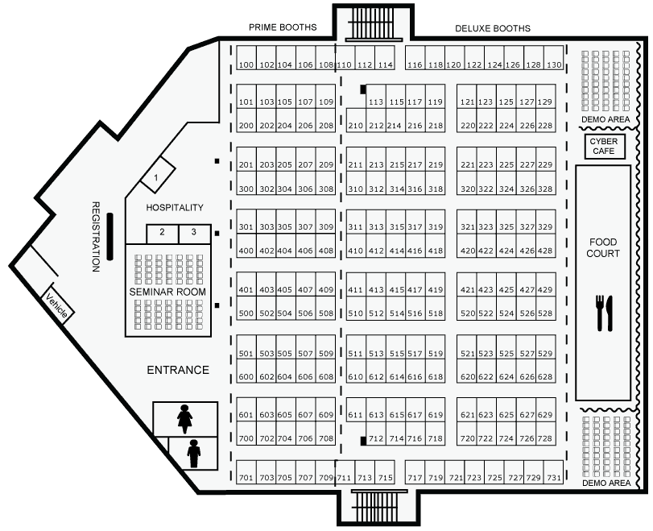
Page3 Initial _____

